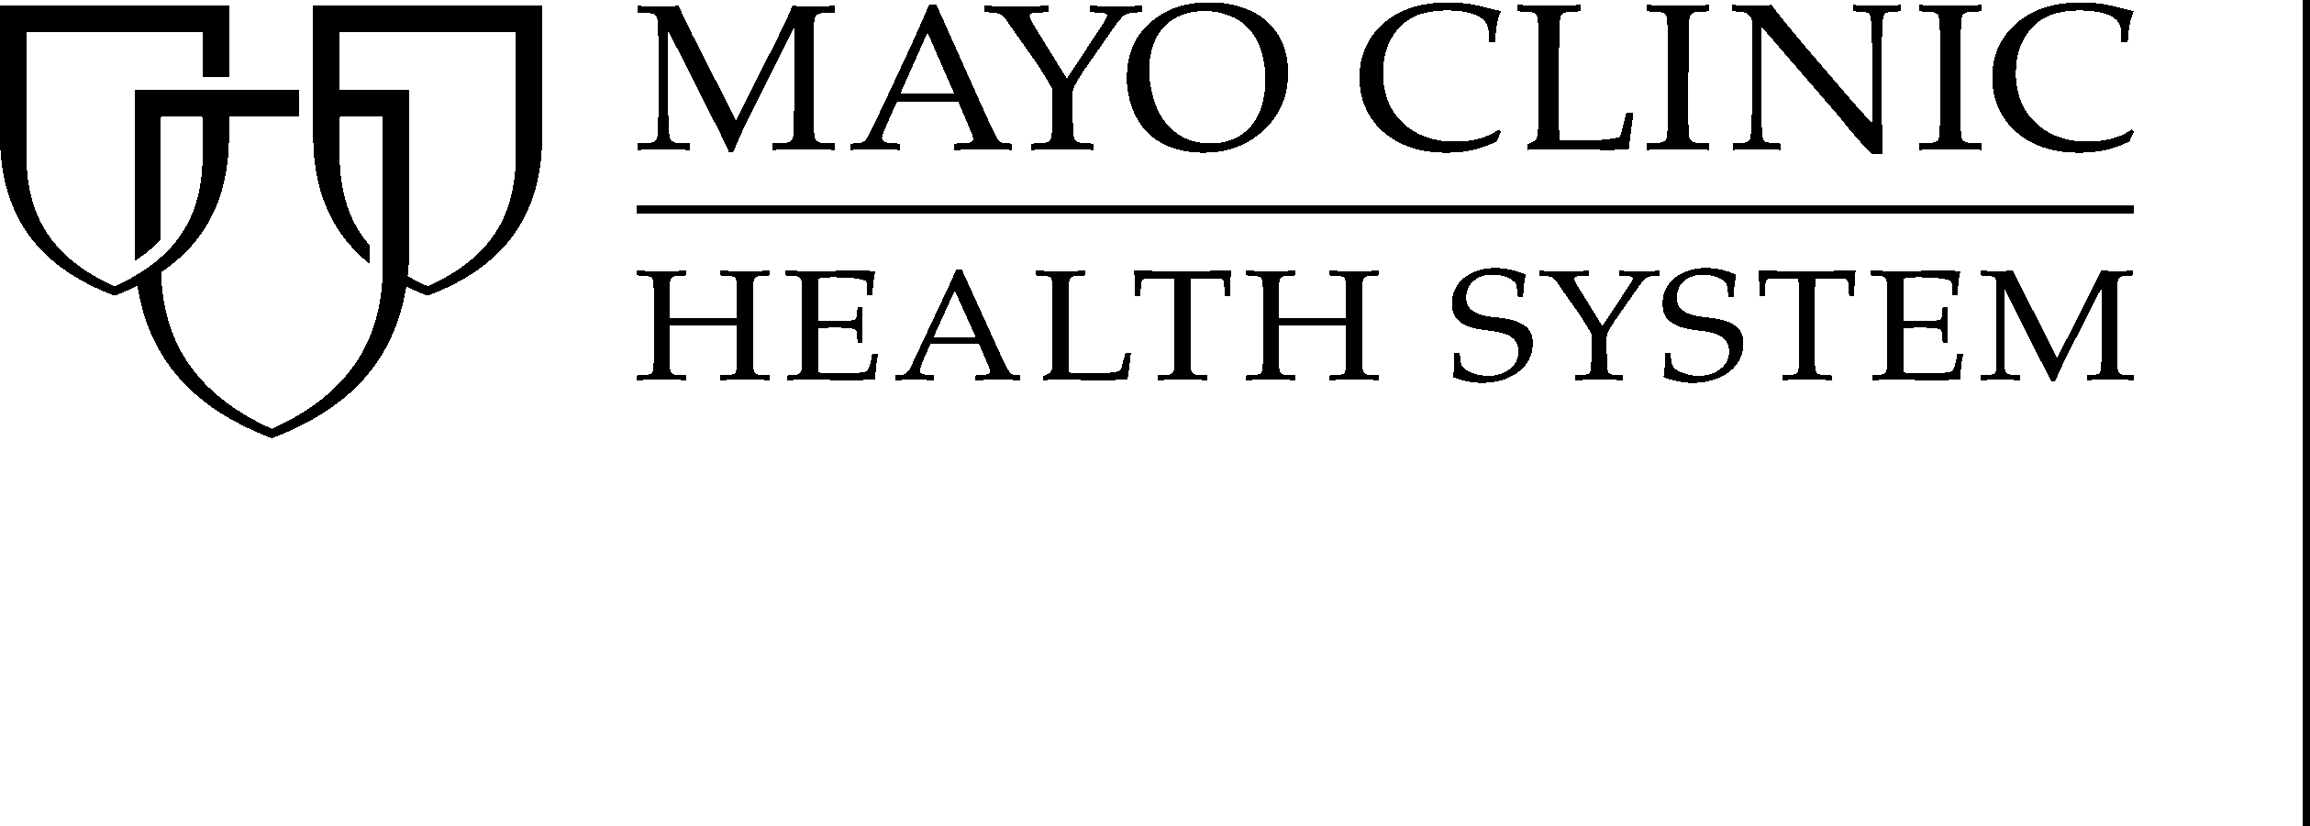
Non-Traditional Scholarship
Public Affairs

SCHOLARSHIP FOR NON-TRADITIONAL* STUDENTS

Mayo Clinic Health System aspires to advance the quality of health care for future generations by providing scholarship opportunities to students in our service area.

AMOUNT: $1,000 (two scholarships awarded)

ELIGIBILITY: . Non-traditional* students in our service area
. Accepted at an accredited college or technical school
. Entering a health care field
. Recipient of a Mayo Clinic Health System Scholarship will not be
eligible to apply for future scholarships offered at our
facility in Austin

* For the purposes of this scholarship, a "non-traditional
student" is one who is pursuing post-secondary education
five (5) years or more after completing high school,
GED, or other post-secondary education.

CONSIDERATIONS: Scholarship applicants will be considered on the basis of the following attributes:

Commitment Character
Leadership Personality/Values
Academic Ability

HOW TO APPLY: Complete the attached application and return to:
Sue Loch
Mayo Clinic Health System
404 West Fountain St
Albert Lea MN 56007

Applications must be received by March 24, 2023.

If you have questions regarding this scholarship, please contact Sue Loch at
507-434-1595 or email at loch.susan@mayo.edu.

Mayo Clinic Health System
Scholarship Application
For Non-Traditional* Students

Please write a brief essay (preferably typewritten) on why you have chosen this health care field,
future goals and ambitions, and how this scholarship would assist you in attaining them.
*For the purposes of this scholarship, a "non-traditional student" is one who is
pursuing post-secondary education FIVE (5) or more years after completing high school,
GED, or other post-secondary education.

PERSONAL INFORMATION

Name ___________________________________________ Phone # _________________

Address __________________________________________________________________________
(Street) (City/State/Zip)

ACADEMIC INFORMATION

High School _________________________________________ Year Graduated: __________

If already enrolled in college, current GPA: __________

COLLEGE INFORMATION

Selected college _______________________________________ Accepted? _______________
(Name) (City/State)

Health care field chosen: ________________________________ GPA: __________________

Length of Program (indicate how far you are if you are already enrolled): __________________

______________________________________________________________________________

WORK EXPERIENCE

List any job (including part-time employment) you have held in the past three years.

Type of Work | Employer | Dates Employed | Hours Per Week

COMMUNITY INVOLVEMENT

Please use the space below to list any community involvement activities you have participated in
the past three years (including school, church, volunteer work, etc.)

Activity | Time  Involved  Hrs/Month | Offices Held or  Honors Received

REFERENCES

Please attach TWO letters of recommendation to this application from individuals who know you well, excluding relatives.

Please return application* to Mayo Clinic Health System, c/o Sue Loch, 404 West Fountain St, MN 56007, by March 24, 2023.

*Complete application should include:

_____ Application Form
_____ Two references
_____ Essay

